Oblique (Diagonal) Line Segment
# Source: AI Source: Provided by: [Data Path: Persons Table -> ID Column: 1, Name_En Column: Motasem Essam] -> From: [ChatGPT] on [7/25/2026]
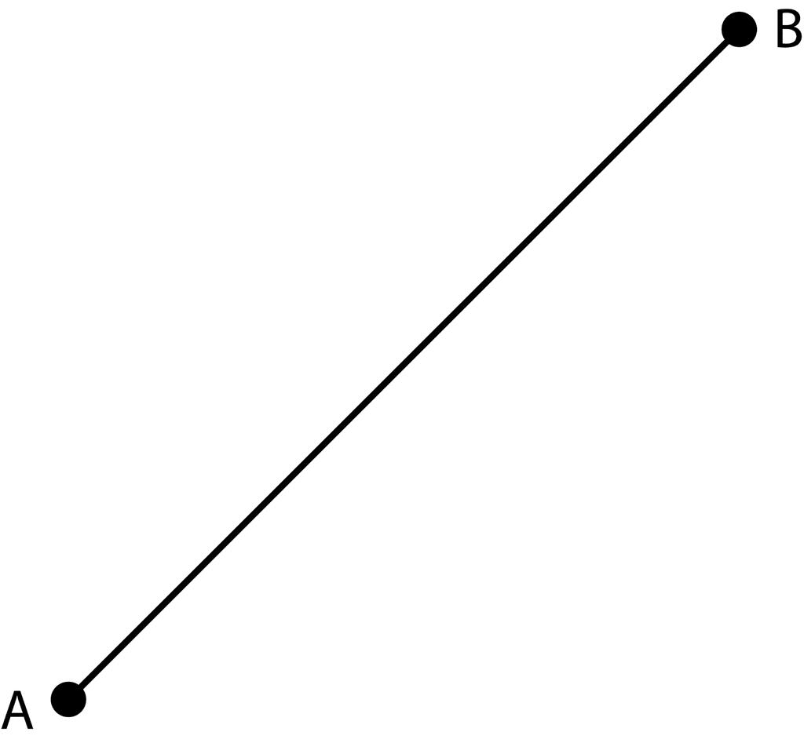
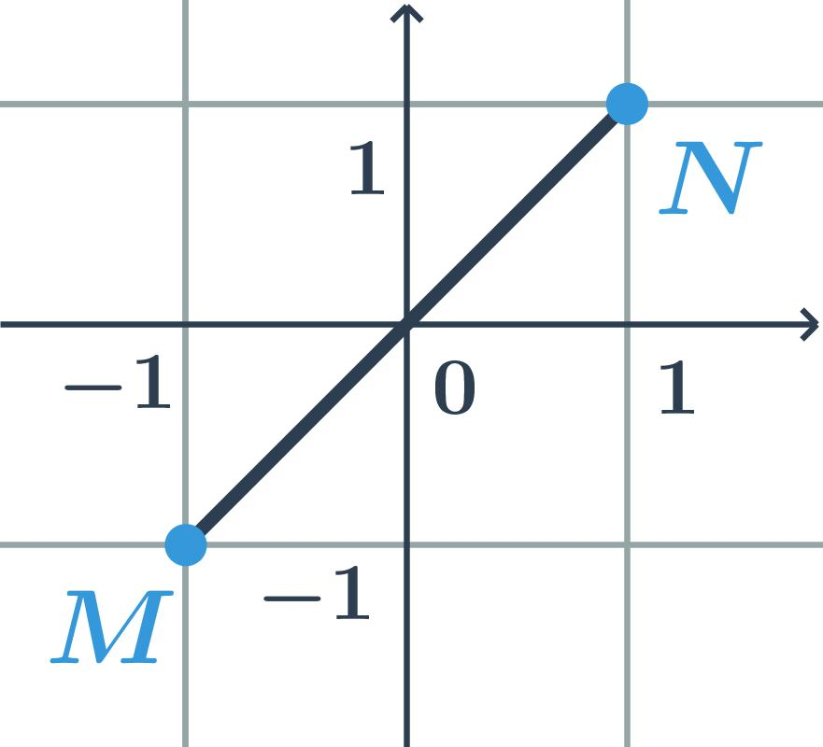
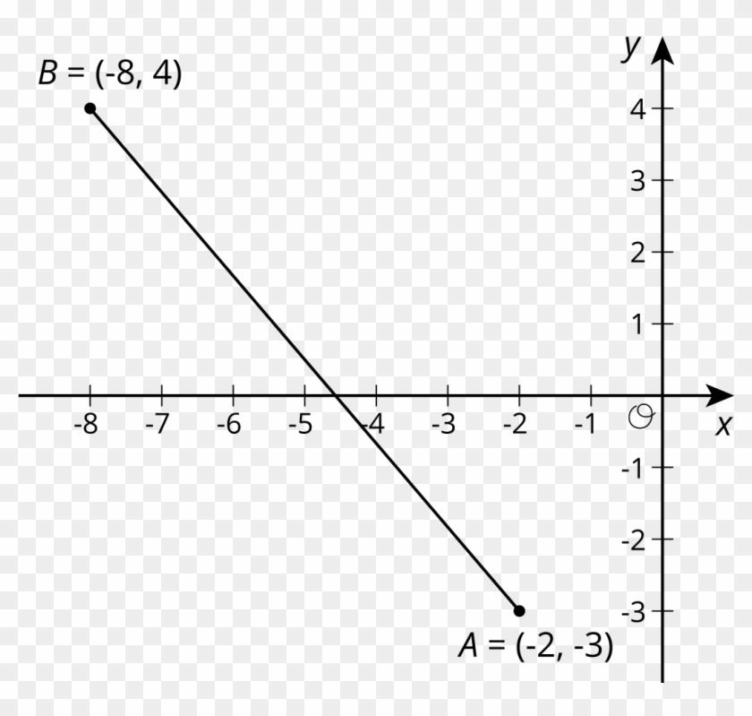
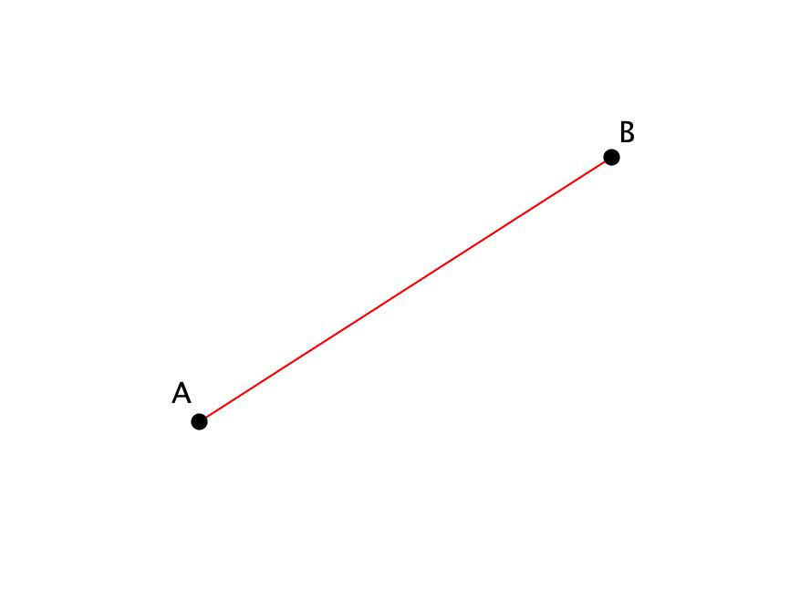
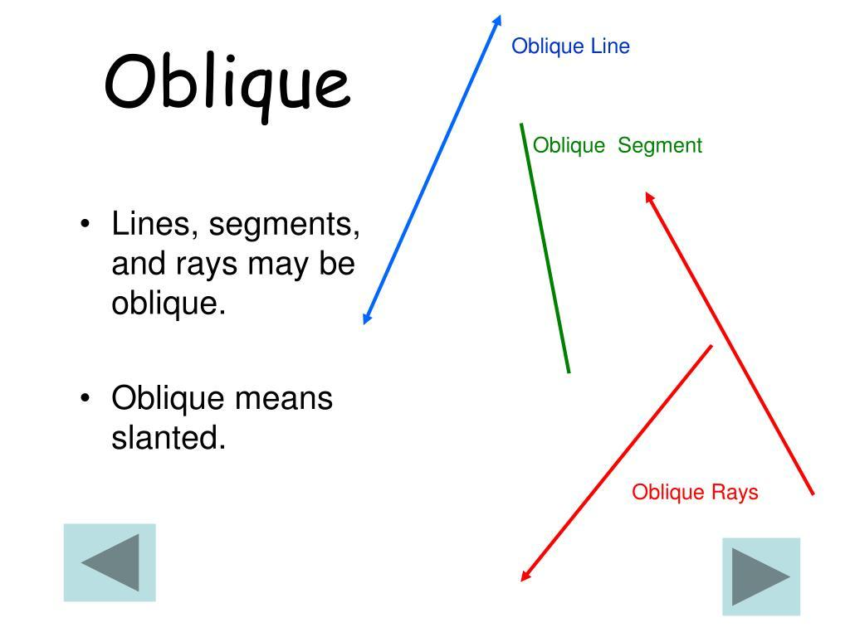

Definition
# Source: AI Source: Provided by: [Data Path: Persons Table -> ID Column: 1, Name_En Column: Motasem Essam] -> From: [ChatGPT] on [7/25/2026]
An Oblique Line Segment (also called a Diagonal Line Segment or Slanted Line Segment) is a finite straight line segment that is neither horizontal nor vertical. It connects two endpoints that have different x-coordinates and different y-coordinates, forming an angle with both the horizontal and vertical directions.
Unlike an oblique line, an oblique line segment has two fixed endpoints and a finite measurable length.

Characteristics
# Source: AI Source: Provided by: [Data Path: Persons Table -> ID Column: 1, Name_En Column: Motasem Essam] -> From: [ChatGPT] on [7/25/2026]
An oblique line segment:
- Has two endpoints.
- Has a finite length.
- Is neither horizontal nor vertical.
- Has a defined, non-zero slope.
- May slope upward or downward.
- Can be measured.

Illustration
# Source: AI Source: Provided by: [Data Path: Persons Table -> ID Column: 1, Name_En Column: Motasem Essam] -> From: [ChatGPT] on [7/25/2026]
Positive Slope
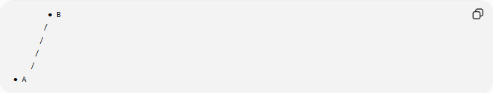
● B
/
/
/
/
● A

Negative Slope
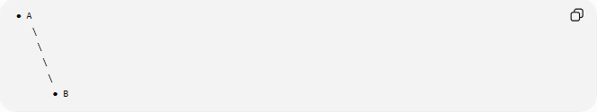
● A
\
\
\
\
● B

Coordinate Geometry
# Source: AI Source: Provided by: [Data Path: Persons Table -> ID Column: 1, Name_En Column: Motasem Essam] -> From: [ChatGPT] on [7/25/2026]
An oblique line segment has endpoints:
$$A\left(x_{1} , y_{1}\right)$$
and
$$B\left(x_{2} , y_{2}\right)$$
where
$$x_{1}≠x_{2}$$
and
$$y_{1}≠y_{2}$$

Length
The length of an oblique line segment is determined using the distance formula:
$$AB=\sqrt{{\left(x_{2}-x_{1}\right)}^{2}+{\left(y_{2}-y_{1}\right)}^{2}}$$

Example
Given:
$$A\left(2 , 3\right) \\ B\left(8 , 7\right)$$
Length:
$$AB=\sqrt{{\left(8-2\right)}^{2}+{\left(7-3\right)}^{2}} \\ =\sqrt{36+16} \\ =\sqrt{52} \\ =2\sqrt{13}$$

Slope
The slope is
$$m=\frac{y_{2}-y_{1}}{x_{2}-x_{1}}$$

Positive Slope Example
$$A\left(1 , 2\right), B\left(5 , 6\right) \\ m=\frac{6-2}{5-1}=1$$
The segment rises from left to right.

Negative Slope Example
$$A\left(2 , 7\right), B\left(8 , 3\right) \\ m=\frac{3-7}{8-2}=-\frac{4}{6}=-\frac{2}{3}$$
The segment falls from left to right.

Examples
# Source: AI Source: Provided by: [Data Path: Persons Table -> ID Column: 1, Name_En Column: Motasem Essam] -> From: [ChatGPT] on [7/25/2026]
Examples of oblique line segments include:
- The diagonal of a rectangle.
- The side of a roof.
- A staircase handrail.
- A ramp.
- A ladder leaning against a wall.

Properties
# Source: AI Source: Provided by: [Data Path: Persons Table -> ID Column: 1, Name_En Column: Motasem Essam] -> From: [ChatGPT] on [7/25/2026]
An oblique line segment:
- Has two endpoints.
- Has finite measurable length.
- Has a non-zero defined slope.
- May have either a positive or negative slope.
- Connects two points with different x- and y-coordinates.

Applications
# Source: AI Source: Provided by: [Data Path: Persons Table -> ID Column: 1, Name_En Column: Motasem Essam] -> From: [ChatGPT] on [7/25/2026]
Oblique line segments are used in:
- Plane Geometry
- Coordinate Geometry
- Engineering
- Architecture
- Construction
- CAD (Computer-Aided Design)
- Surveying
- Technical Drawing
- Computer Graphics
- Robotics

Advantages
# Source: AI Source: Provided by: [Data Path: Persons Table -> ID Column: 1, Name_En Column: Motasem Essam] -> From: [ChatGPT] on [7/25/2026]
Studying oblique line segments helps to:
- Measure diagonal distances.
- Apply the distance formula.
- Calculate slopes.
- Construct geometric figures.
- Model inclined structures.

Limitations
# Source: AI Source: Provided by: [Data Path: Persons Table -> ID Column: 1, Name_En Column: Motasem Essam] -> From: [ChatGPT] on [7/25/2026]
An oblique line segment:
- Has finite length.
- Exists only between its endpoints.
- Represents only one inclined direction.

Comparison with Related Objects
# Source: AI Source: Provided by: [Data Path: Persons Table -> ID Column: 1, Name_En Column: Motasem Essam] -> From: [ChatGPT] on [7/25/2026]
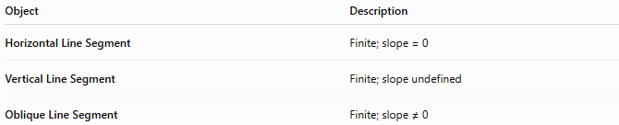
Object | Description
Horizontal Line Segment | Finite; slope = 0
Vertical Line Segment | Finite; slope undefined
Oblique Line Segment | Finite; slope ≠ 0

Key Points
# Source: AI Source: Provided by: [Data Path: Persons Table -> ID Column: 1, Name_En Column: Motasem Essam] -> From: [ChatGPT] on [7/25/2026]
- An Oblique (Diagonal) Line Segment is a finite straight segment that is neither horizontal nor vertical.
- It has two endpoints.
- It has a measurable length:
$$AB=\sqrt{{\left(x_{2}-x_{1}\right)}^{2}+{\left(y_{2}-y_{1}\right)}^{2}}$$
- Its slope is:
$$m=\frac{y_{2}-y_{1}}{x_{2}-x_{1}}$$
where
$$m≠0$$
- It may have either a positive or negative slope.
- Oblique line segments are widely used in geometry, engineering, architecture, surveying, CAD, construction, and computer graphics.

Conclusion
# Source: AI Source: Provided by: [Data Path: Persons Table -> ID Column: 1, Name_En Column: Motasem Essam] -> From: [ChatGPT] on [7/25/2026]
An Oblique (Diagonal) Line Segment is a finite straight segment connecting two points that differ in both their horizontal and vertical coordinates. It has a measurable length, a defined non-zero slope, and may rise or fall depending on the relative positions of its endpoints. Oblique line segments are essential in plane geometry, coordinate geometry, engineering, architecture, construction, surveying, CAD, technical drawing, robotics, and computer graphics, where they are used to represent diagonals, inclined structures, ramps, and sloping connections while enabling accurate calculations of distance and slope.

